Cacti Install manual

May 10, 2007
Jun Sakai

This manual describe how to set up Cacti servers

1. Install APACHE, PHP, MySQL, SNMP 3
2. Install RRDTOOL 3
3. Install Cacti 3
4. INSTALL Cactid 4
5. INSTALL Plugin Architecture 4
6. INSTALL Plugins (ex.Thold) 4
7. Install Net-Snmp into Client 5
8. Access Cacti Administrator page 6
8.1 Login 6
8.2 Setting 7

1. Install APACHE, PHP, MySQL, SNMP

shell> yum -y install httpd php php-mysql php-snmp mysql mysql-server net-snmp net-snmp-utils

2. Install RRDTOOL

shell> yum -y install freetype-devel libart_lgpl-devel libpng-devel zlib-devel
shell> yum -y ruby-devel tcl-devel python-devel
shell> wget http://oss.oetiker.ch/rrdtool/pub/rrdtool.tar.gz
shell> tar zxvf rrdtool
shell> cd rrdtool-1.2.23
shell> ./configure
shell> make
shell> make install

3. Install Cacti

shell> cd /var/www/html/
shell> tar xzvf cacti-version.tar.gz
shell> mv cacti-0.8.6j cacti
shell> mysqladmin --user=root create cacti
shell> mysql cacti < cacti.sql
shell> mysql --user=root mysql

mysql> GRANT ALL ON cacti.* TO cactiuser@localhost IDENTIFIED BY 'somepassword';
mysql> flush privileges;

shell> vi include/config.php

$database_default = "cacti";
$database_hostname = "localhost";
$database_username = "cactiuser";
$database_password = "cacti";

shell> useradd cactiuser
shell> chown -R cactiuser rra/ log/

vi /etc/crontab

*/5 * * * * cactiuser php /var/www/html/cacti/poller.php > /dev/null 2>&1

Point your web browser to:

http://your-server/cacti/

Log in the with a username/password of admin.
You will be required to change this password immediately.
Make sure to fill in all of the path variables carefully and correctly on the following screen.

4. INSTALL Cactid

shell> yum –y install mysql-devel
shell> wget http://www.cacti.net/downloads/cactid/cacti-cactid-0.8.6i.tar.gz
shell> tar zxvf cacti-cactid-0.8.6i.tar.gz
shell> cd cacti-cactid-0.8.6i
shell> ./configure
shell> make
shell> make install

5. INSTALL Plugin Architecture

shell> http://cactiusers.org/downloads/cacti-plugin-arch.tar.gz
shell> tar zxvf cacti-plugin-arch.tar.gz
shell> mv cacti-plugin-arch/* /var/www/html/cacti
shell> cd /var/www/html/cacti/
shell> patch -p1 -N < cacti-plugin-0.8.6j.diff

6. INSTALL Plugins (ex.Thold)

shell> /var/www/html/cacti/plugins
shell> wget http://cactiusers.org/downloads/thold.tar.gz
shell> tar zxvf thold.tar.gz
shell> vi /var/www/html/cacti/include/config.php
$plugins = array();
$plugins[] = 'thold';

7. Install Net-Snmp into Client

shell> yum -y install net-snmp
shell> vi /etc/snmp/snmpd.conf

# com2sec SecurityName Network ComunitiName
com2sec securenet 192.168.20.0/24 sakaijun

#group GroupName ModelName SecurityName
group secure_group v1 securenet
group secure_group v2c securenet
group secure_group usm securenet

#SMTP Information
view all included .1 80

#Access
access secure_group "" any noauth exact all none none
access secure_group "" any noauth exact all all non

syslocation Right here, right now
syscontact Root <sakai@aplogics.com> (configure /etc/snmp/snmp.local.conf)

8. Access Cacti Administrator page

8.1 Login
Access http://localhost/cacti/

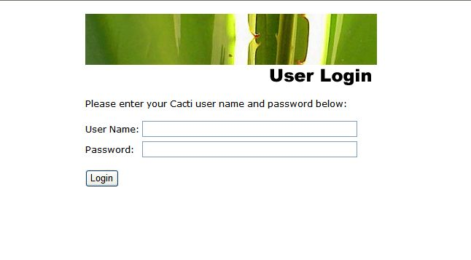
Username: admin
Password: admin

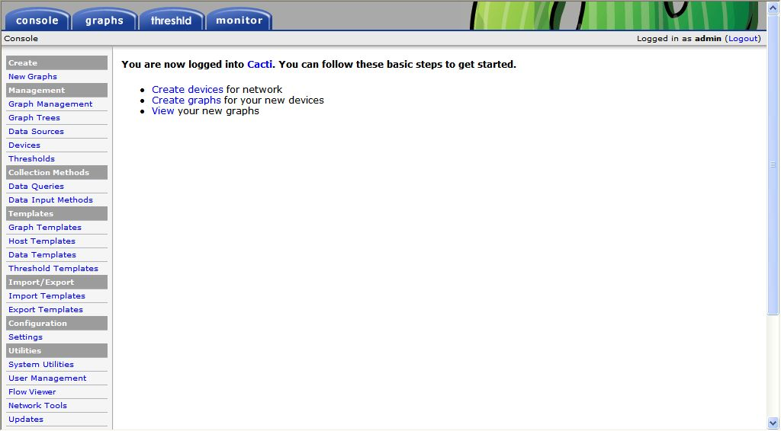

8.2 Setting
Click “Settings” on left memu
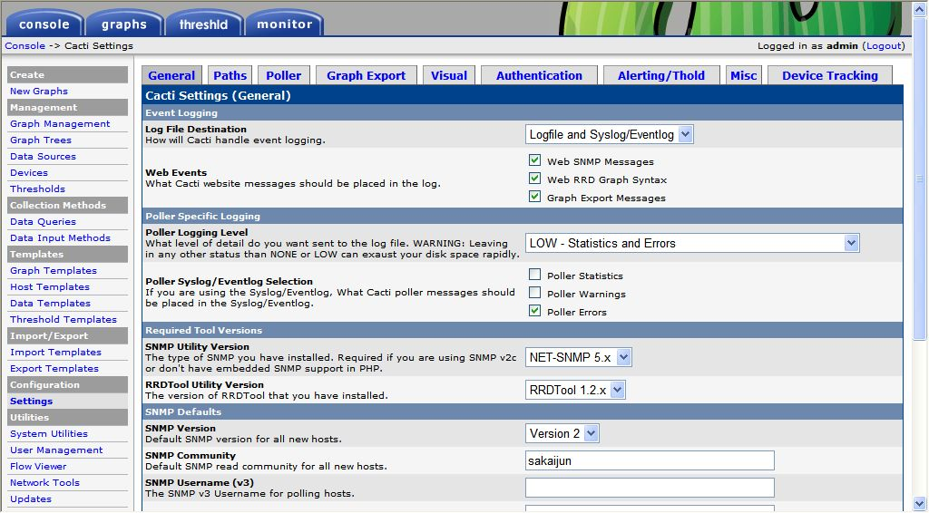
- Select “NET-SNMP” 5.x in SNMP Utility Version
- Select “RRDTool 1.2.x” in RRDTool Utility Version

Click “Paths” tab, and then type correct command path.
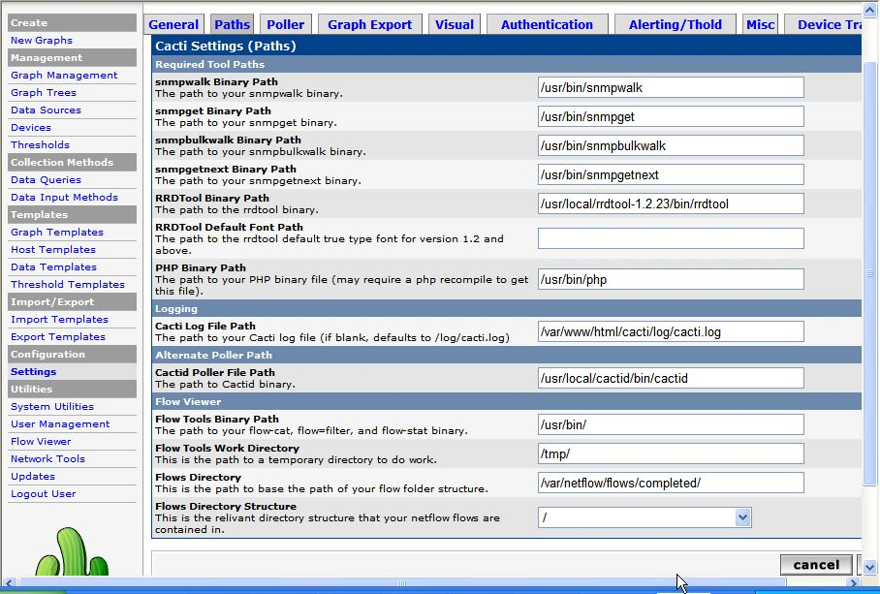
You can register each Server which you want to monitor. Click “Devices” on left menu and make.
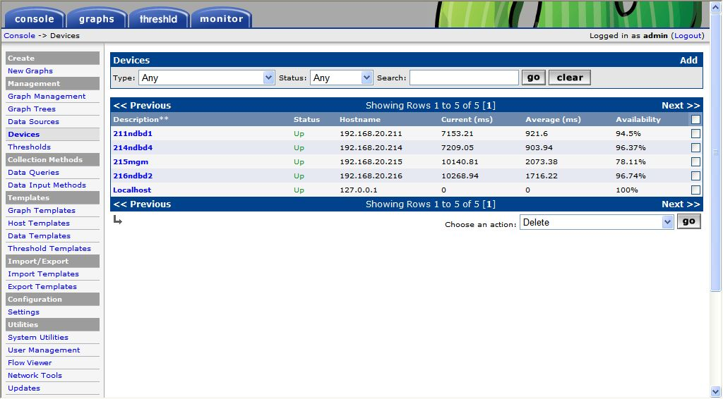

You can see some information of server like as follow
